Setting up Summer School

For the new Summer School code for 2019, there are two ways to build the records and pay each employee.
OPTION #1
- Build a new extra duty code in Tables>Salaries>Extra Duty for Summer School Teacher.

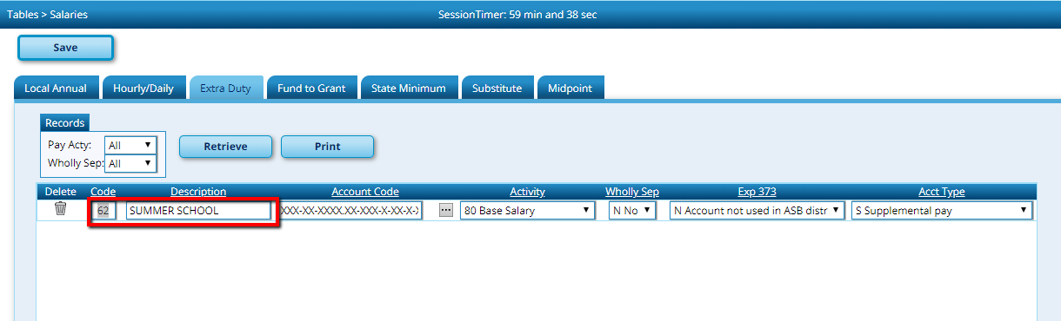

- Build a new school calendar for summer school in Tables>Workday Calendars. Choose begin and end dates as usual.

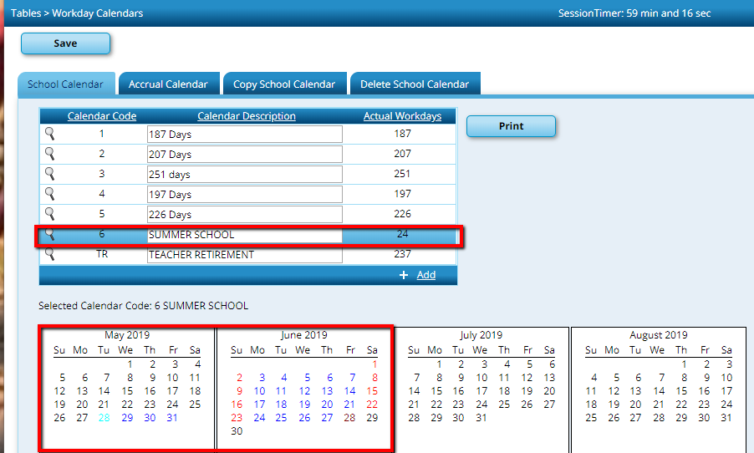

- Build the Summer School Contracts through Maintenance>Summer School Contracts.

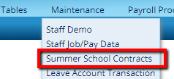
Add each summer school teacher and assign the new Summer School Calendar.

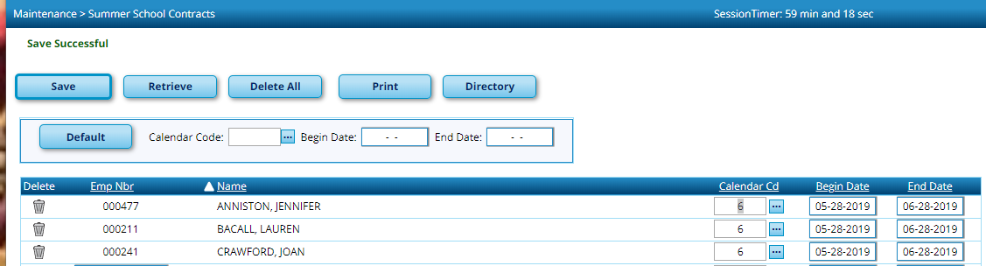

- Add Summer School pay as an extra duty amount under Hours/Pay Transmittals>Extra Duty, assigning the Extra Duty Code for Summer School.

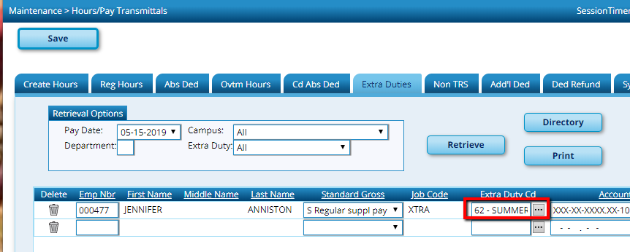

This option will create an ED 40 for teachers. Payment for aides, cafeteria, bus, etc. can continue be added as extra duty in the same way we always have.
NOTE: This option will not create a line on the service record, which could be helpful for employees that may not have worked enough days to get a year of TRS service credit. If this is needed, the line would have to be manually added, or you may choose option 2.
OPTION #2
The second option for reporting the Summer School pay is to actually build another job on the Job Info tab.
- Build new job codes(s) for Summer School (i.e. Summer School Teacher, Summer School School Cafeteria, Summer School Bus Driver) in Tables>Job Codes.

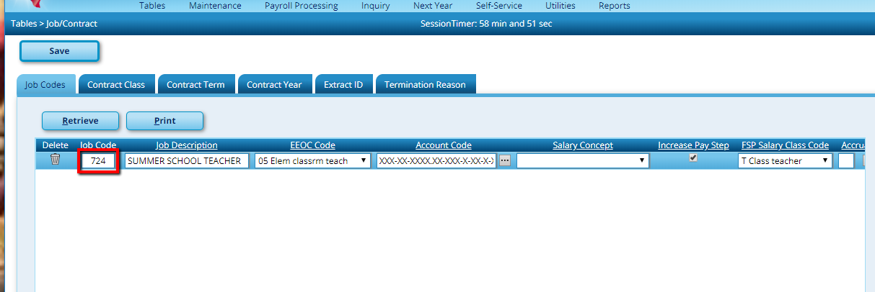

- Build Summer School Calendar. See step 2 on page 1.

- From Maintenance Staff/Job Pay Data add a new contract for the Summer School Teacher position. Summer School Teachers should be assigned a TRS Position Code 09 to ensure proper Stat Min. Calculations. Support staff will use the same TRS Position Code used during the year (04-Bus Driver, 07-Cafeteria, etc.).

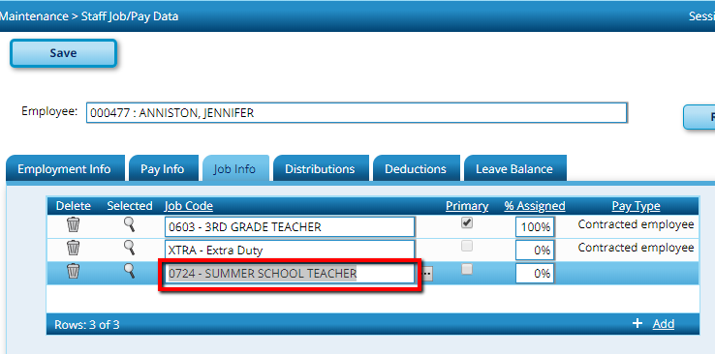

Summer school job may be set up to pay hourly (Pay Type 3), or as a set amount, payable in 1-3 payments (Pay Type 1 or 2). Distributions should be set to org 699 for summer School per FAR Guide.

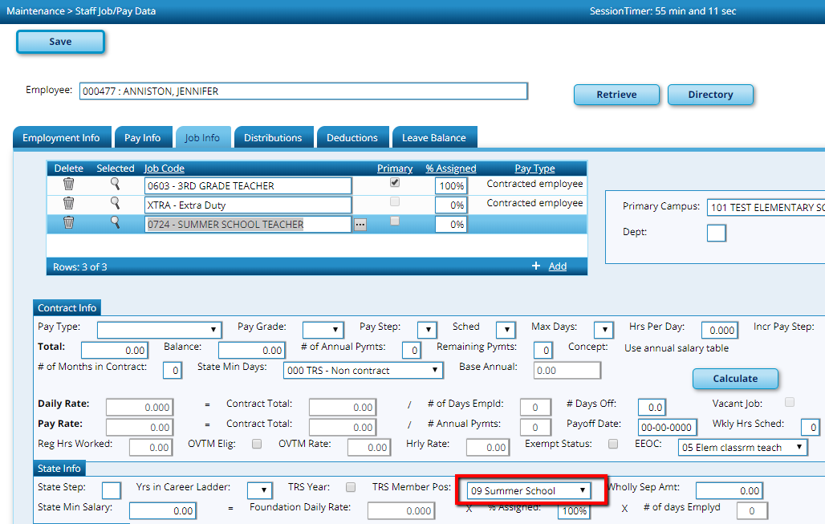

- Process payroll as usual.

NOTE: This option will create a line on the service record, which may be helpful for employees that may not have worked enough days to get a year of TRS service credit. This would also be applicable on any summer school employee. TRS is mainly concerned with teachers and setting them up so they will not have Stat Min charged on Summer School employment.

